# Multilingual Social Media Analytics

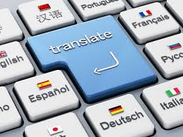

Language Translation Web Application

Abstract :

The Language Translation Web Application is a Flask-based web application designed to facilitate the translation of text between multiple languages. Leveraging the Google Translate API and the langdetect library, this application provides users with a simple and intuitive interface for translating text and detecting the language of individual words.

Keywords :

Flask, Google Translate API, langdetect, Language Translation, Machine Translation, Web Application.

Introduction :

Language translation is a crucial component of global communication, enabling individuals and businesses to overcome linguistic barriers and interact effectively across cultures. The Language Translation Web Application aims to simplify the process of translating text between different languages by providing a user-friendly web interface.

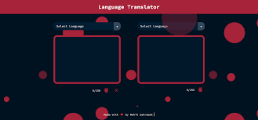

Language Identification For Machine Translation :

One of the key challenges in machine translation is accurately identifying the language of the input text . Language identification is essential for selecting the appropriate translation model and ensuring accurate translation results

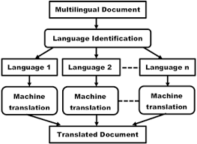

Challenges Involved In Language Identification :

Multilingual text : Texts containing multiple language present challenges for language identification algorithms .

Code-Switching : Code-Switching , where speakers alternate between languages within a single sentence or conversation , complicates language identification .

Low-Resource Languages : Identifying language with limited training data poses challenges for machine learning models.

Machine Translation :

Machine translation is the process of automatically translation text from one language to another language translation web application utilizes the google Translate API to perform machine translation and provide users with accurate translate in real-time

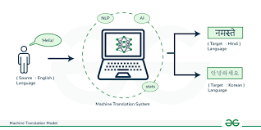

Methodology :

The Language Translation Web Application is built using the Flask web framework, which allows for rapid development of web applications in Python. The application integrates with the Google Translate API for language translation and utilizes the langdetect library for language identification.

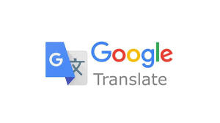

Related Work :

Several other tools and platforms exist for language translation and machine translation. These include open-source projects like Moses, OpenNMT, and Marian, as well as commercial translation services like Microsoft Translator and Amazon Translate.

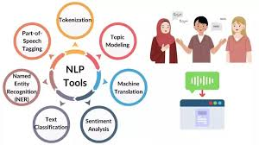

Literature Survey :

A comprehensive literature survey on language translation and machine translation reveals a wealth of research and development in this field. Researchers have explored various approaches to improving translation accuracy, including neural machine translation, domain adaptation, and multilingual models.